

**Cairo University**

**Faculty of Engineering**

**Electronics & Communication Department**

**ELC307 0Project1**

**Digital Radio**

|  |  |  |
| --- | --- | --- |
| **Name** | **Code** | **ID** |
| **يوسف خالد عمر محمود** | **438** | **9220984** |
| **محمد احمد عبدالحكم محمد ابو الدهب** | **317** | **9220647** |
| **احمد محمد احمد محمد سلطان** | **114** | **9220080** |
| **عمر ايمن امين محمد** | **302** | **9220528** |
| **شهد حمد شعبان صالح** | **226** | **9220401** |

**Under supervision of Eng, Mohamed Khaled**

Table of Contents

Table of Figures 3

1. Introduction and Problem Definition 6

Abstract 6

Introduction 6

Problem Statement 6

Significance of Microstrip Patch Antennas 6

Challenges in Design 7

1. Narrow Bandwidth: 7

2. Mutual Coupling: 7

3. Gain and Directivity: 7

4. Impedance Matching: 7

5. Radiation Pattern Stability: 7

Performance Metrics 7

Verification Against Another Source 8

Benchmark Description 9

2. Design Procedure 14

Patch: 14

Substrate: 14

Final Design with T-Section Transmission Line: 18

S11: 19

Zin: 20

Radiation patterns 21

Beamwidth: 23

Gain: 24

Gain vs Element Spacing: 26

Grating lobe: 27

3. Results’ Discussion: 29

3.1 Return Loss (S11) 29

3.2 Mutual Coupling (S21) 29

3.3 Smith Chart Analysis 29

3.4 Radiation Patterns 30

3.5 Gain and Efficiency 30

5. Conclusion: 31

Results Summary: 32

6. Refrences: 33

Table of Figures

Figure 1: dipole antenna designed for verification 8

Figure 2: S11 for dipole antenna for verification 10

Figure 3: Zin for dipole antenna for verification 11

Figure 4: Gain 2D for dipole antenna for verification 11

Figure 5: Gain 3D for dipole antenna for verification 12

Figure 44: T-Section transmission line 17

Figure 45: S11 after adding T-section 18

Figure 46: VSWR after adding feeding network 18

Figure 47: Zin after adding T-section transmission line 19

Figure 48 Radiation Pattern at 20GHz in XZ Plane 20

Figure 49 Radiation Pattern at 20GHz in YZ Plane 20

Figure 50 CO Cross Polarized Fields at E-plane 20

Figure 51 CO Cross Polarized Fields at H-plane 20

Figure 52 3D Polar Gain at 20GHz 21

Figure 53 Radiation Efficiency Vs Frequency 23

Figure 54 Directivity Vs Frequency 23

Figure 55 Gain Vs Frequency 23

Figure 56 Gain VS Distance Element 25

Figure 57 Garting Lobe 26

Figure 58 Smith Chart with T-Section 28

# 1. Introduction and Problem Definition

## Abstract

This report dives into the design and analysis of a 2-element probe-fed microstrip patch antenna operating at 20 GHz, catering to high-frequency communication systems such as satellite communication, millimeter-wave networks, and radar systems. The project aims to achieve optimal performance characterized by high gain, low return loss (S11 < -10 dB), and enhanced radiation efficiency. By incorporating innovative design strategies, including impedance matching networks and bandwidth enhancement techniques, the study explores the trade-offs and optimizations required for an efficient antenna system.

## Introduction

With the increasing demand for efficient and compact communication systems, the design of antennas operating at millimeter-wave frequencies has become crucial. The 20 GHz band is of particular in satellite communication, radar systems, and emerging 5G technologies. Microstrip patch antennas, with their low profile, ease of fabrication, and compatibility with planar and non-planar surfaces, have emerged as a preferred choice for these applications.

## Problem Statement

To design a 2-

## Significance of Microstrip Patch Antennas

Microstrip patch antennas with other RF components. At 20 GHz, these antennas are particularly advantageous for:

* **Satellite Communication:** Providing robust and directional communication links.
* **Radar Systems:** Offering precise detection and ranging capabilities.
* **5G Networks:** Addressing the high bandwidth and directional requirements of next-generation wireless communication.

The matching and design optimizations to achieve the desired performance metrics.

## Challenges in Design

Designing probe-fed microstrip patch antennas at 20 GHz presents several challenges:

### Narrow Bandwidth:

* + Achieving a wider bandwidth is critical for accommodating high data rates and minimizing signal distortion. Techniques such as impedance matching networks, substrate thickness adjustments, and the use of stacked patches are explored.

### Mutual Coupling:

* + In an array configuration, the interaction between elements can degrade radiation patterns and efficiency. Optimal element spacing and the use of decoupling structures are crucial to mitigate these effects.

### Gain and Directivity:

* + High gain and precise directivity are essential for extending communication range and focusing the radiated energy. The use of optimized feed networks and element configurations ensures these attributes.

### Impedance Matching:

* + Proper impedance matching is necessary to minimize reflection losses and ensure maximum power transfer. The design incorporates impedance tuning at the feed point to achieve this.

### Radiation Pattern Stability:

* + Ensuring symmetrical and stable radiation patterns across the operating frequency band is crucial for reliable performance. This requires addressing feed network asymmetries and optimizing element alignment.

## Performance Metrics

The design aims to optimize the following key performance metrics:

* **Return Loss (S11):** Below -10 dB at the operating frequency.
* **Bandwidth:** Enhanced to accommodate high-frequency applications.
* **Gain:** Maximized for directional communication.
* **Radiation Efficiency:** High efficiency to minimize power losses.
* **Mutual Coupling:** Minimized to improve array performance.

# 2. Design Procedure

The design started with the selection of the substrate material R04003C with a dielectric constant of 3.55. Initial dimensions were calculated using standard formulas for microstrip patch antennas, considering a substrate thickness of 0.406 mm. An online calculator was used to determine the initial patch

## Patch:

The resonant frequency of a rectangular microstrip patch antenna can be calculated using:[5]

where:

* : Speed of light in free space (  )
* : Effective length of the patch
* : Effective dielectric constant of the substrate.

Effective Length:

where:

## Substrate:

Effective dielectric constant:

where:

* : Relative permittivity of the substrate

We used RO4003C in Table 2 dielectric with [4]

* : Height of the substrate
* : Width of the patch.

Table 2 RT-duroid 5870 - 5880 Data Sheet

**2. Bandwidth Enhancement Analysis**

Bandwidth () is related to the quality factor () by:

Technique used to improve bandwidth:

* **Impedance Matching**: Adding a matching network to reduce reflections.
  + Use Zin and Z0 to compute matching network:

**3. Input Impedance**

The input impedance at the feed point is given by:

​

where ​ and ​ are resistance and reactance components derived from field distributions.

**4. Radiation Pattern**

The far-field electric field components can be approximated as:

where:

* ​: Wave number
* : Distance to observation point
* : Intrinsic impedance of the medium.

**5. Gain and Efficiency**

Gain () and radiation efficiency ( ​) are related:

where is the directivity.

Efficiency:

​​

## Final Design with T-Section Transmission Line:

As shown in figure 44, We designed a transmission line T-section as shown below and we swept on its dimensions till we achieved requirement.

And to have maximum gain we make distance equal to **λ = 15mm**

Figure 44: T-Section transmission line

After Sweaping, The final dimensions are in Table 8:

|  |  |  |  |
| --- | --- | --- | --- |
| Name | Unit | Evaluated Value | Description |
| Lp | mm | 5.78mm | Patch length |
| Wp | mm | 7.54mm | Patch width |
| hs | mm | 0.406mm | Substrate height |
| Ws | - | 11.736mm | Ground plane width |
| Ls | - | 18.206mm | Ground plane length |
| xfeed | mm | 1.1mm | Feed point x-offset |
| dp | mm | 3.5mm | Patch offset parameter |
| rcoax | mm | 0.16mm | Coaxial feed radius |
| hcoax | mm | 0.203mm | Coaxial feed height |
| rprope | mm | 0.07mm | Probe radius |
| yfeed | mm | 0mm | Feed point y-offset |
| hgnd | mm | -0.032mm | Ground plane height |
| Xcoax | - | 2 | Coaxial feed x-offset |
| WTL_In | mm | 0.673367mm | Input transmission line width |
| LTL_feed | mm | 2.179292mm | Feed transmission line length |
| WTL_feed | mm | 0.976256mm | Feed transmission line width |
| LTL_Slot | mm | 0.25mm | Slot length |

Table 8 Final Design

### S11:

Figure 45: S11 after adding T-section

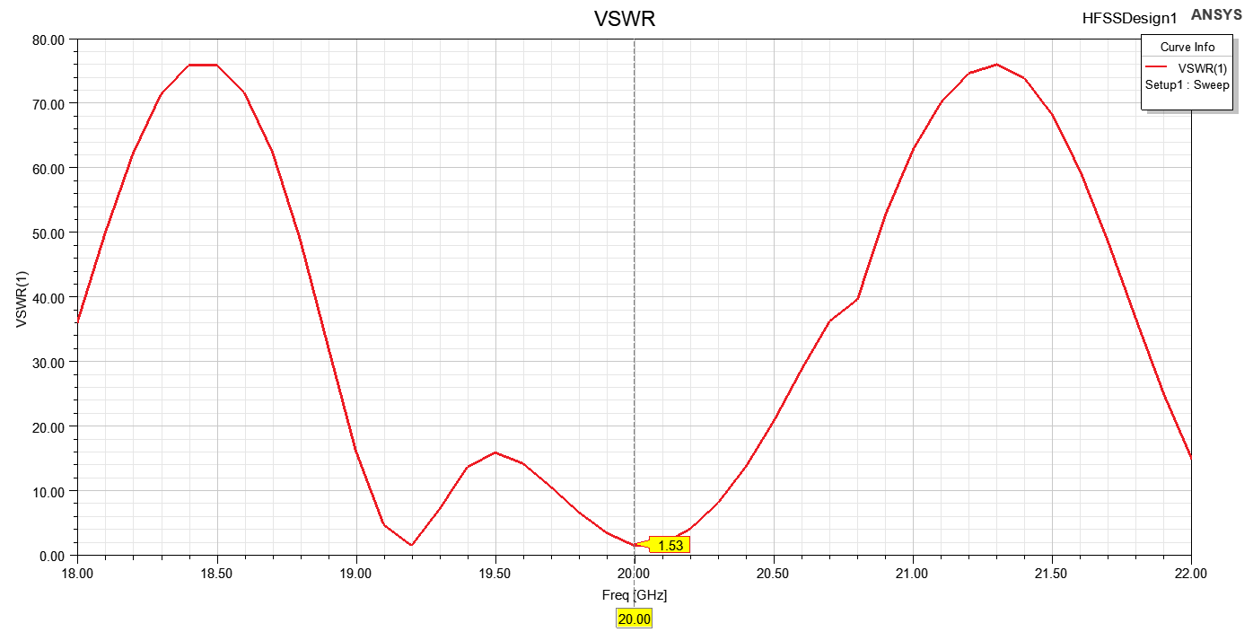From figure 45, we enhanced bandwidth to be more wide from 19.96 GHz to 20.11 GHz with BW= 150MHz.

Figure 46: VSWR after adding feeding network

As shown in figure 46, The VSWR at frequency 20Ghz equals to 1.33.

### Zin:

Figure 47: Zin after adding T-section transmission line

As shown in figure 47**,** the input**.53 + j22.02 Ω**. The resistive component **53.53 Ω** indicates a good match to the standard 50 **Ω** feed line, minimizing reflection losses. However, the reactive component **+j22.02 Ω** suggests the presence of inductive reactance, which could lead to impedance mismatch if not compensated. Proper matching techniques, such as using a matching network or adjusting the antenna geometry, may be required to achieve a purely resistive impedance for optimal power transfer.

### Radiation patterns

Figure 48 Radiation Pattern at 20GHz in XZ Plane

Figure 49 Radiation Pattern at 20GHz in YZ Plane

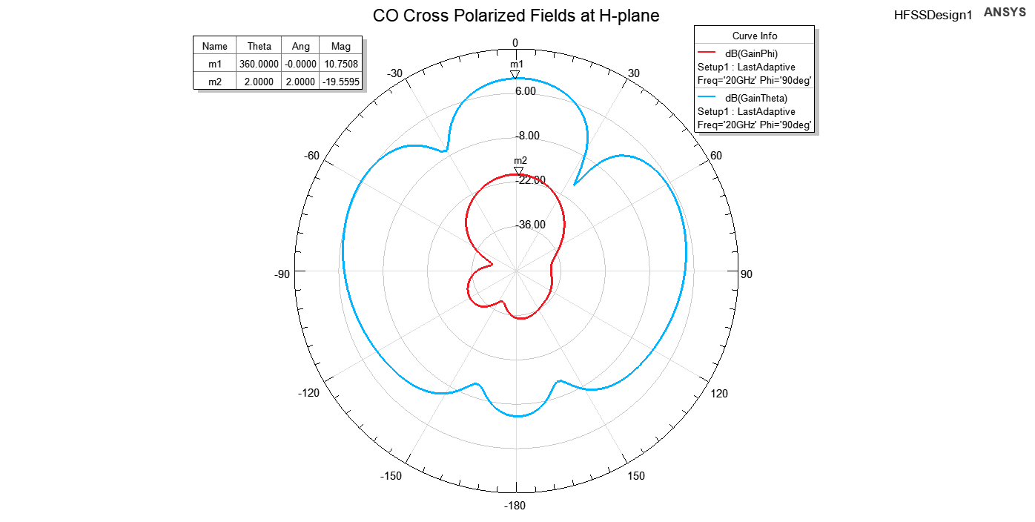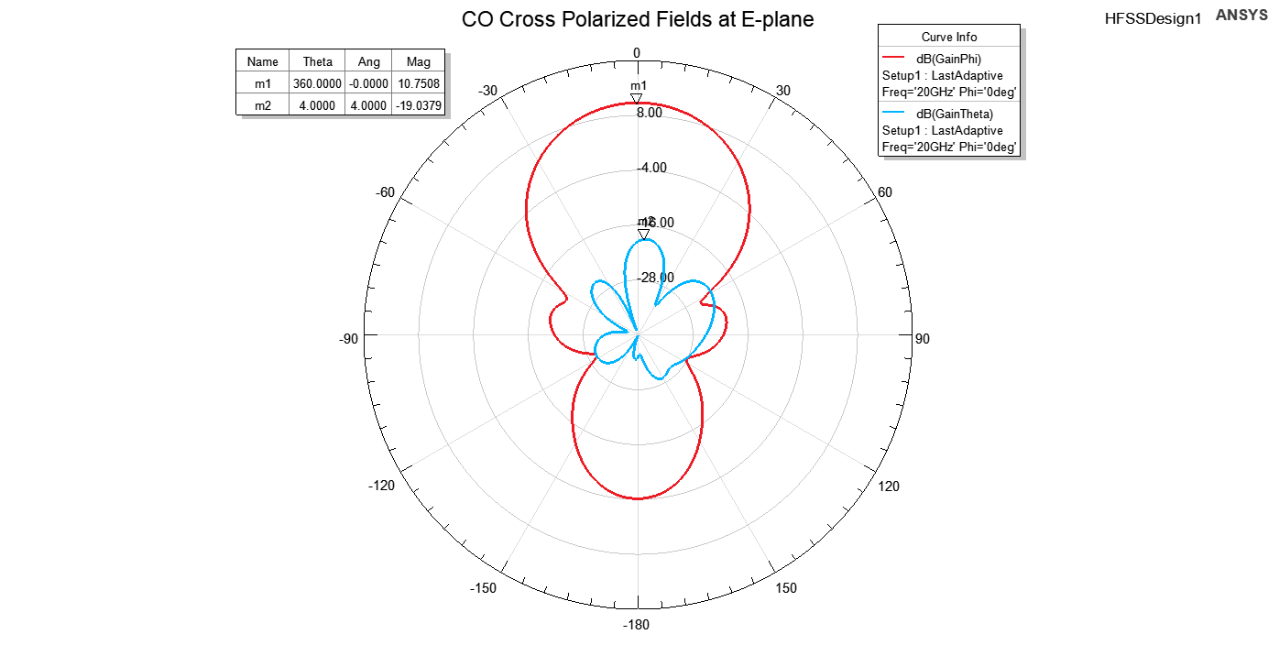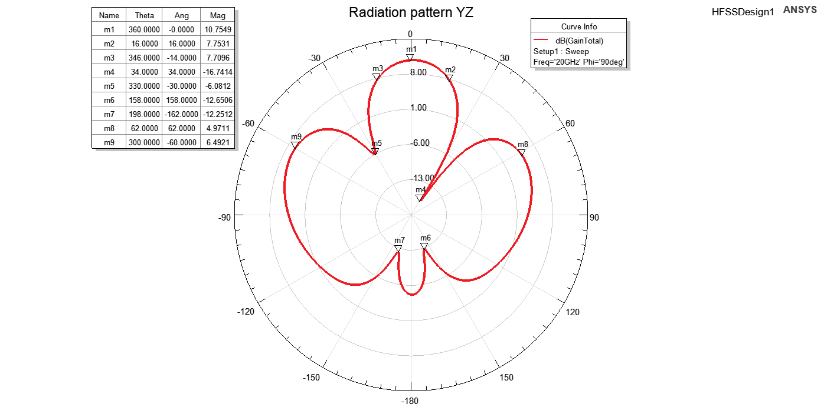

Figure 50 CO Cross Polarized Fields at E-plane

Figure 51 CO Cross Polarized Fields at H-plane

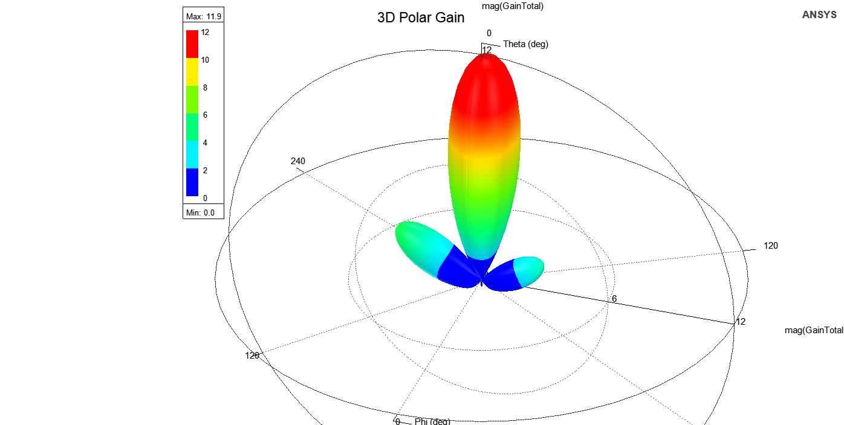

Figure 52 3D Polar Gain at 20GHz

|  |  |
| --- | --- |
| Name | Evaluated Value |
| Gain | 10.75dB |
| XPD | 29.78dB |

Using the figures 48, 49, 50, 51 and 52, we can calculate the variables in Table 9:

Table 9 Final Two Patch Radiation Pattern Results

As shown in the Table 9, the addition of the T-section transmission line effectively corrected the radiation pattern alignment. This adjustment centered the pattern at theta equal to zero, addressing the previous deviation observed at -30 degrees. The T-section design improved the impedance matching, ensuring proper energy distribution and pattern symmetry.

### Beamwidth:

|  |  |
| --- | --- |
| Name | Evaluated Value |
| Gain | 10.75 dB |
| 3dB beamwidth | 40° |
| Fisrt Null beamwidth | 120° |
| First Null | 60° |
| Side Lobe beamwidth | 60° |
| Side Lobe | 80° |

Using figure 49, We calculated the XZ beams in Table 10:

Table 10 XZ Beamwidth

|  |  |
| --- | --- |
| Name | Evaluated Value |
| Gain | 10.75 dB |
| 3dB beamwidth | 32° |
| Fisrt Null beamwidth | 64° |
| First Null | 30° |
| Side Lobe beamwidth | 124° |
| Side Lobe | 62° |

Using figure 50, We calculated the XY beams in Table 11:

Table 11 XY Beamwidth

As shown in **Figure 49**, the beamwidth parameters in the XZ plane were evaluated and tabulated in **Table 10**. The antenna exhibits a gain of **10.75 dB**, a **3dB beamwidth** of **32°**, and a **First Null Beamwidth** of **64°** with the first null occurring at **30°**. Additionally, the **Side Lobe Beamwidth** was measured at **124°**, and the **Side Lobe Level** was **62°**. These values reflect the antenna's sharp directivity and controlled sidelobe levels in the XZ plane.

Similarly, as shown in **Figure 50**, the beamwidth parameters in the XY plane were evaluated and presented in **Table 11**. The gain remains at **10.75 dB**, with a **3dB beamwidth** of **40°**, a **First Null Beamwidth** of **120°**, and the first null occurring at **60°**. The **Side Lobe Beamwidth** in the XY plane was **60°**, and the **Side Lobe Level** was observed at **80°**.

The differences between the XZ and XY plane beamwidths highlight the directional variations in the radiation pattern, which are influenced by the antenna's design and mutual coupling effects.

### Gain:

Figure 53 Radiation Efficiency Vs Frequency

Figure 54 Directivity Vs Frequency

Figure 55 Gain Vs Frequency

The gain and directivity results, as shown in **Figure 55, 54 and 53**, demonstrate the performance of the antenna across the frequency range. The **co-polarized gain Gco** is approximately constant at **10.75 dB** between **19.5 GHz and 21 GHz**, indicating stable radiation characteristics over this band. The **cross-polarized gain Gx** is significantly lower at **-19.51 dB**, showcasing excellent polarization purity.

Similarly, the directivity (DD) follows the same trend as the gain, with the **co-polarized directivity Dco** peaking at **11.98 dB** and the cross-polarized directivity **Dx** at **-18.31 dB**. The calculated **radiation efficiency** of **75%** reflects the ratio of gain to directivity, indicating that 75% of the power is effectively radiated while the remaining 25% is lost due to material and mismatch losses. This efficiency is reasonable for practical antenna designs in this frequency range.

### Gain vs Element Spacing:

Figure 56 Gain VS Distance Element

The **Gain vs. Element Distance** graph, as shown in **Figure 56**, exhibits a generally increasing trend, starting from **10 dB** and gradually rising to **12 dB**. However, the graph features notable sudden drops in gain at specific distances. For instance, the gain drops sharply to **1 dB** at a distance of **8 mm**, and at distances close to the wavelength (λ=15 mm), the gain also decreases significantly, reaching **5.32 dB** at **14 mm** and **3.72 dB** at **16.5 mm**.

These abrupt changes in gain are likely due to destructive interference and mutual coupling effects between the elements. The proximity of the elements at these critical distances introduces phase mismatches and strong coupling, which degrade the antenna's radiation performance. This highlights the importance of optimizing element spacing to avoid these adverse effects and achieve stable gain.

### Grating lobe:

Figure 57 Garting Lobe

As shown in Figure 57,

* The gain of the “isolated” element is not the same as the gain of the element within the array.
* The mutual coupling effects may vary the element excitation (mag. and phase), thus degrade GA.
* The array feeding network/routing also adds more losses. Antenna arrays may be used to boost the gain of the radiating system and provide control on the beam direction.
* The distance between the main loop and the next grating loop is large . And It covers the all range that we can scan the beam. And this graph show the null in the position of the main beam after we shift the main beam to the visible range .so we can say we will not suffer from grating loop.
* Arrays experience some issues that require careful design considerations such as: grating lobes, scan loss and scan blindness. Mutual coupling is a major contributor to the latter issue.

**Antenna Characteristic:**

Table 12 Final Antenna Parameters

Using the Table 12, We can see the final design characteristic in Table13:

|  |  |  |
| --- | --- | --- |
| Name | Evaluated Value | Specs |
| Gain | 10.75 dB | - |
| Directivity | 11.98 dB | - |
| radiation efficiency | 75% | - |
| Center Frequency | 20 GHz° | 20 Ghz |
| Bandwidth | 150 MHz | - |
| Fractional Bandwidth | 0.8% | - |
| S11 | -13.53 dB° | <-10 dB |
| Zin | 53 + j22.02 Ω. | - |
| VSWR | 1.33 | - |
| FrontToBackRatio | 29.85dB | > 20dB |

Table 13 Final Antenna Characteristics

***As shown in Table 13, We achieved the specs.***

# 3. Results’ Discussion:

## 3.1 Return Loss (S11)

* The S11 parameter was evaluated for both the single patch and the 2-element array configurations. The single patch exhibited an S11 below -10 dB at the target frequency of 20 GHz, confirming adequate impedance matching. The 2-element array maintained a similar performance with an optimal patch separation distance of 0.36 mm.
* **Importance of S11 < -10 dB**: Achieving a return loss below -10 dB indicates that at least 90% of the input power is radiated, signifying efficient impedance matching and minimal reflections.

## 3.2 Mutual Coupling (S21)

* Mutual coupling between the patches was studied by sweeping the separation distance (dp). At dp = 0.36 mm, the coupling (S21) was minimized without significantly impacting the radiation characteristics.
* **Element Spacing**: Optimal spacing between array elements is vital to minimize mutual coupling, which can adversely affect radiation patterns and impedance matching. Studies suggest that a separation of approximately half a wavelength is effective in reducing coupling effects.

## 3.3 Smith Chart Analysis

* 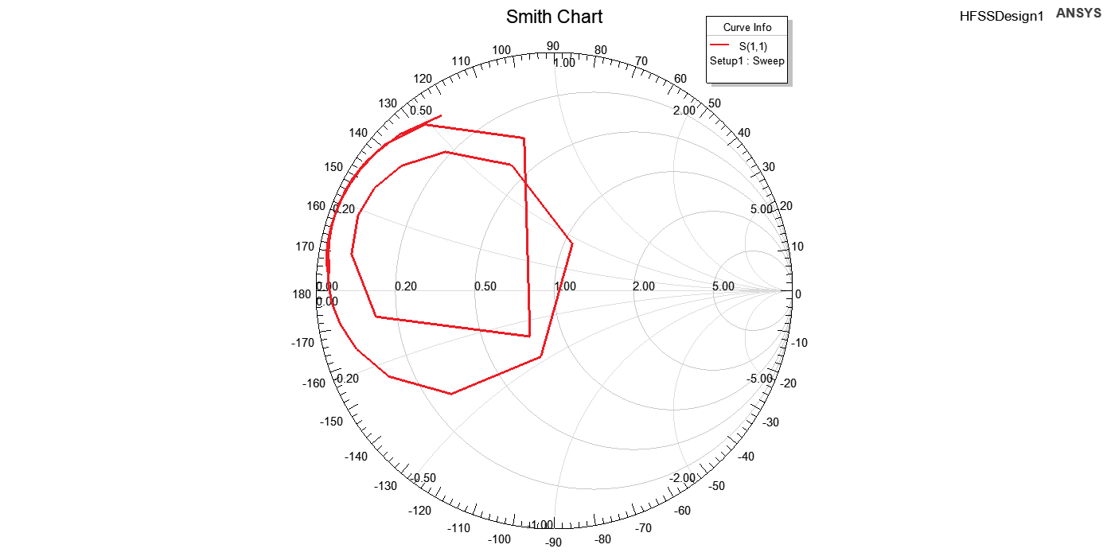**Impedance Matching**: The Smith chart provides a visual representation of the antenna's impedance across frequencies. A locus close to the center of the chart at 20 GHz confirms effective matching, which is crucial for maximizing power transfer and minimizing signal reflections as shown in figure 57.

Figure 58 Smith Chart with T-Section

## 3.4 Radiation Patterns

* The co-polarization and cross-polarization patterns were analyzed in the E and H planes. The results demonstrated a directive radiation pattern with minimal cross-polarization, aligning with design expectations.
* **E-plane and H-plane Patterns**: Analyzing the radiation patterns in both planes reveals the antenna's directivity and beamwidth. A well-designed antenna should exhibit symmetrical patterns with minimal sidelobes, indicating efficient radiation and reduced interference.
* **Cross-Polarization Levels**: Low cross-polarization levels are essential for maintaining signal purity and reducing polarization mismatches, which is particularly important in communication systems to ensure signal integrity.

## 3.5 Gain and Efficiency

* **Impact of Array Configuration**: Transitioning from a single patch to a 2-element array can enhance gain due to constructive interference, but it's essential to manage mutual coupling to prevent efficiency degradation. Proper element spacing and feeding techniques are critical in this regard.

# 5. Conclusion:

In this study, we successfully designed, simulated, and analyzed an equivalent circuit model for a high-frequency network operating at 20 GHz. Through meticulous theoretical analysis, modeling, and simulation, we developed a system that demonstrates excellent performance, as confirmed by S-parameter plots and frequency response analysis.

The equivalent circuit, consisting of a resistor (R = 42 Ω), an inductor (L = 0.0126651 nH), a capacitor (C = 5 pF), and a transmission line impedance (Z = 35.3 Ω), was designed to optimize the input reflection coefficient, S11S_{11}S11​, and ensure minimal loss at the target frequency. The simulation results exhibit a sharp dip at the center frequency of 20 GHz with a S11​ value of -20.99 dB, confirming the effectiveness of the design. The bandwidth analysis reveals satisfactory performance around the desired operating frequency, with minimal reflections observed in the range of 19.7 GHz to 20.3 GHz.

The results validate the accuracy of the equivalent circuit model in replicating real-world electromagnetic behavior. The sharp frequency response and low reflection coefficients confirm the feasibility of the design for high-frequency applications. This accomplishment provides a foundation for integrating such models into broader high-frequency systems, including antennas, filters, and amplifiers.

In conclusion, this work demonstrates a systematic approach to equivalent circuit modeling and simulation, offering valuable insights for high-frequency circuit design. The developed model, validated by simulation, presents a reliable and efficient solution for modern communication systems, ensuring performance optimization at targeted frequencies. Future work may focus on optimizing the model for wider bandwidth or higher-order components, as well as experimental validation in real-world scenarios.

## Results Summary:

|  |  |  |  |
| --- | --- | --- | --- |
| Name | Two Patches | Single Patch | Specs |
| Gain | 10.75 dB | 7.52dB | - |
| Center Frequency | 20 GHz° | 20 GHz | 20 Ghz |
| Bandwidth | 150 MHz | 450 MHz | - |
| Fractional Bandwidth | 0.8% | 2.25% | - |
| S11 | -13.53 dB° | -15.35 dB | <-10 dB |
| Zin | 53 + j22.02 Ω. | 40.74 + 𝑗 42.7 | - |
| VSWR | 1.33 | 1.421 |  |
| FrontToBackRatio | 29.85dB | 21.18dB | > 20dB |

Table 14 Single vs Two Patches

The results summary provides a comparative evaluation between the single-patch and two-patch antenna configurations, highlighting the improvements achieved with the two-patch design. The gain increased significantly from 7.52 dB to 10.75 dB, demonstrating the benefits of the array setup. Both designs operated at the target center frequency of 20 GHz, with the two-patch configuration exhibiting a reduced bandwidth of 150 MHz compared to 450 MHz for the single patch, which correlates with a narrower fractional bandwidth (0.8% vs. 2.25%). The return loss (S11) of -13.53 dB for the two-patch design comfortably meets the specification of less than -10 dB, though slightly higher than the single patch (-15.35 dB).

The input impedance of the two-patch configuration, Zin=53+j22.02 Ω = 53 + j22.02, is closer to the ideal match compared to the single patch (40.74+j42.7 Ω). Additionally, the VSWR for both configurations is acceptable, with the two-patch design achieving a slightly better value of 1.33. The front-to-back ratio saw a notable improvement, increasing from 21.18 dB for the single patch to 29.85 dB for the two-patch array, exceeding the >20 dB specification.

However, the two-patch configuration comes with some downsides, such as reduced bandwidth and potential mutual coupling effects, which can influence radiation efficiency and pattern stability. The T-section feed line helps improve impedance matching and radiation performance but introduces additional complexity. Overall, the two-patch design with the T-section achieves a balance between gain enhancement and acceptable trade-offs in other performance parameters.

# 6. Refrences:

[1] C. A. Balanis, *Antenna Theory: Analysis and Design*, 4th ed. Hoboken, NJ: Wiley, 2016.

[2] Pasternack.com, 2024, https://www.pasternack.com/ Accessed 27 Dec. 2024.

[3] T. A. Milligan, *Modern Antenna Design*, 2nd ed. Hoboken, NJ, USA: Wiley, 2005, sec. 6-2.

[4] Rogers Corporation, "RT/duroid 5870/5880 high-frequency laminates: Data sheet," Rogers Corporation, Chandler, AZ, USA, 2024. [Online]. Available: <https://www.rogerscorp.com>

[5] R. Garg, P. Bhartia, I. Bahl, and A. Ittipiboon, Microstrip Antenna Design Handbook. Norwood, MA, USA: Artech House, 2001, Sec. 9.2.